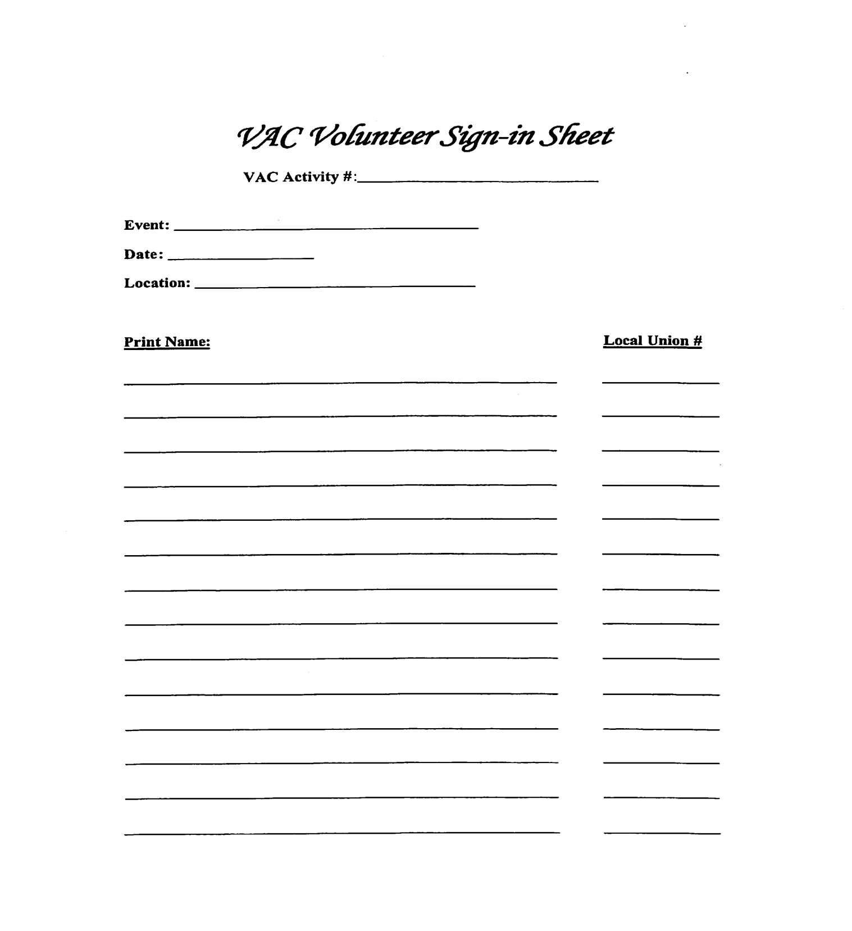

By signing in as a participant in the VAC Program, each participant agrees to comply with all the rules and procedures of the Program. Including, but not limited to: Sign-in sheets, applications, paperwork deadlines etc. It is also the individual’s responsibility to be in communication with their VAC Coordinator and or Business Representative regarding all submitted paperwork, and eventual qualification to attend the VAC Banquet. Sign in sheets and applications must be submitted within 30 days of the event to receive credit.